Lab 02: Datums with Projections
Due date: Midnight (11:59 pm) on Monday, Sep 8, 2025 submitted as Word document to blackboard Lab02 link
This lab counts 6.67 % (60 points out of 900 points) toward your total grade.

In this exercise, you will work with projections in ArcGIS at a variety of scales. The goal of this exercise is for you to gain an understanding and appreciation of how projections can be appropriately used and how they impact your maps.

Topics covered in this exercise include:
- Determine the projection of your data layers in ArcGIS Pro
- Change the display projection of your map in ArcGIS Pro
- Describe how projections may distort geometric properties
- Discuss key criteria in determining an appropriate map projection
- Re-project data layer

Step 1. Open a Map Project

First, we need to download and open the Exercise_2.aprx file.
- Download the Exercise_2.zip file. Save it to the location of your choosing. You will need to extract the compressed files by right-clicking on Exercise_2.zip. In the drop-down window, choose ‘Extract All’.
- Within the uncompressed folder ‘Exercise_2’, directly click on the Exercise_2.aprx to open this project file.
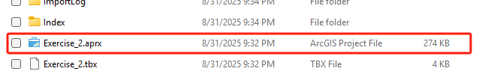
This project contains a total of five maps: AR, US, World, Asia, and Europe. We will begin with the AR map. Each map is displayed in a different tab.
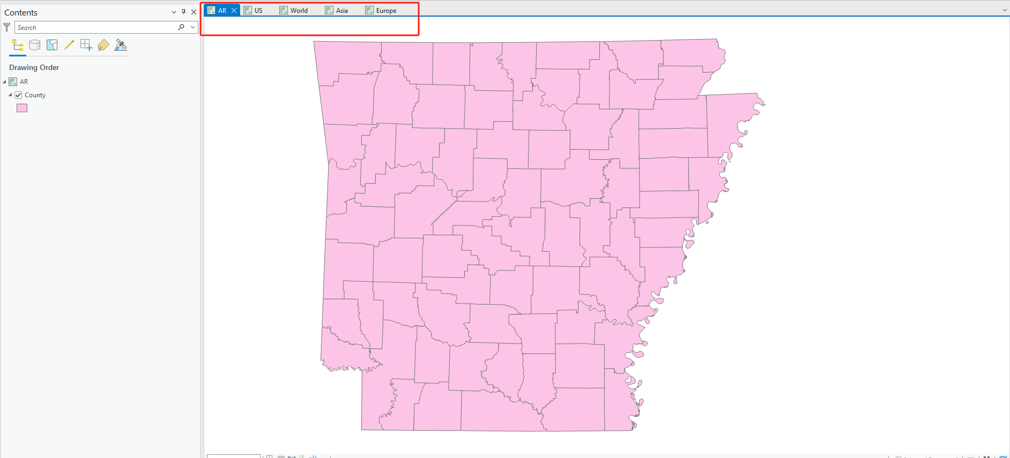

Step 2. Exploring Layer Datum and Projection Information
The AR map only includes one layer, County. Layers in a map commonly have a datum defined and maybe a map projection to which the coordinates are referenced. This may be different from the map. Note that ArcGIS allows for projection-on-the-fly, in which data layers can be re-projected in memory so that they draw at the correct location relative to a map projection. This is a nice feature, as it allows you to load data that have different datum and/or projections defined into the same map space.
Here, we will investigate the projection information for the County layer.
- Right-click on the County layer in the table of contents. Select Properties (it should be at the bottom of the window).
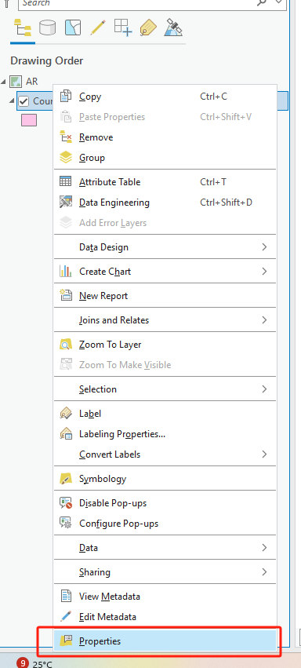
- In the Layers Properties Window, navigate to the Source options.
- Within the Source options, expand the Spatial Reference information.
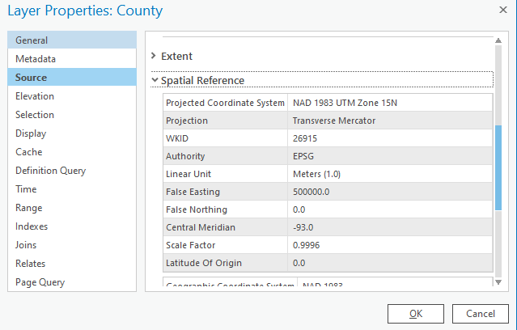
This provides information about the Projected and Geographic coordinate systems used for this data layer. Use this information to answer the following questions.

Question 1. What is the projected coordinate system for this layer? (4 Points)

Question 2. What is the datum for this layer? (4 Points)

Question 3. In what linear unit are the measurements specified? (4 Points)
You can use this menu to investigate spatial reference information for any geospatial layer.

Step 3. Changing Map Projections
Although each data layer is assigned either a projected coordinate system or a geographic coordinate system, the spatial reference for a data layer can be transformed. So, you can view the map space or map layouts in different projections as ArcGIS Pro can apply these transformations on-the-fly, or in memory. Here, we will explore changing the projection of a map. We will now work with the US map. Before we change the projection, we will explore the UTM zones and State Plane Coordinate Systems.
- Navigate to the US Map.
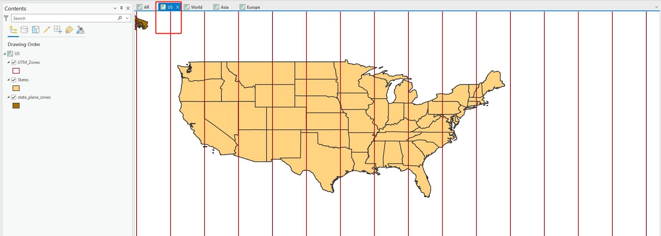
The regions on the map that are separated by vertical red lines represent different UTM zones. If you click within a zone, information about the zone will be displayed.
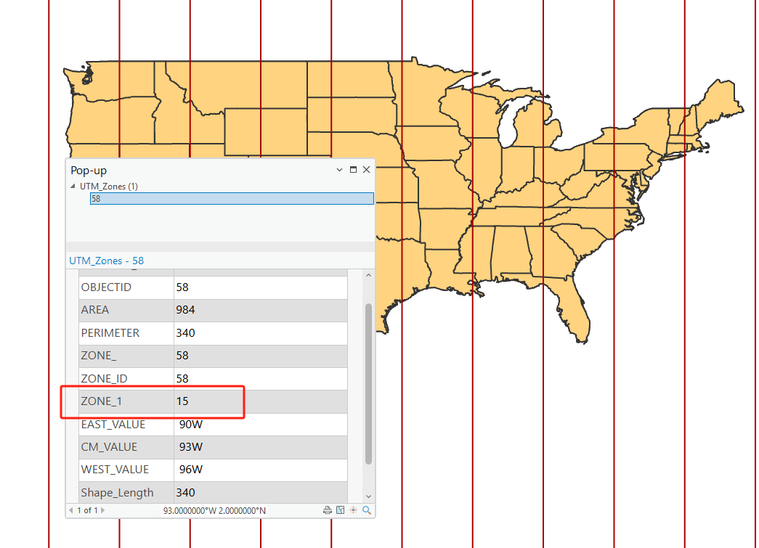
The zone number is listed in the “Zone_1” field. Use this information to answer the following questions.

Question 4. In what UTM zone is Arkansas located? (4 Points)

Question 5. How does the zone number change as you move east across the United States? (4 Points)
You will now investigate the state plane coordinate systems.
- Turn off the UTM_Zones by un-checking it in the Contents Pane.
- Let us make the States layer only have an outline by changing the symbology as we did in exercise 1.
Recap:

- Double-click on the polygon symbology for States in the Contents Pane.
- Click on Properties in the Symbology Window. o Click on the Symbol Options (looks like a brush).
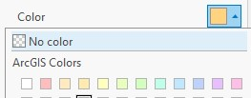
- Change the Color to “No Color”.

- Change the Outline Color, and Outline Width to settings you feel are appropriate.
- Click Apply to accept the changes.

You should now see the state plane systems within each state.
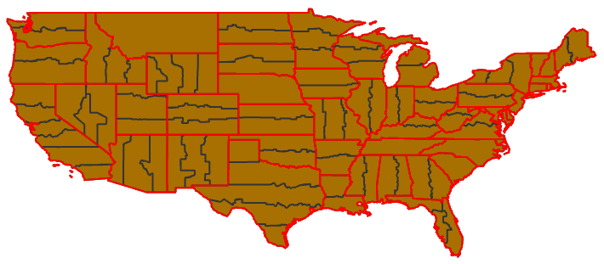

Question 6. How many state plane systems does Arkansas have? (4 Points)
Now, you will change the projection for this map. Before we begin, let’s turn off all of the layers except the States layer.
- Make sure that the States layer is displayed. Make sure that it is checked on in the Contents Pane.
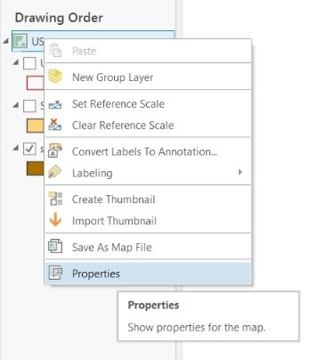
- Make sure that the UTM_Zones and state_plane_zones layers are not displayed. Make sure that they are unchecked in the Contents Pane.
Now, you are ready to change the projection.
- In the Contents Pane, right-click US. In the menu that is activated select Properties.
- In the Map Properties window, navigate to Coordinate Systems.

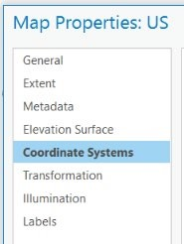

We will now change the projection to an Albers Equal Area Conic projection.
- Within the Coordinate Systems window, expand the Projected Coordinate Systems list. Expand the Continental list. Expand the North America list.
- From the North America list, select USA Contiguous Albers Equal Area Conic.
- Click OK to change the projection of the map.
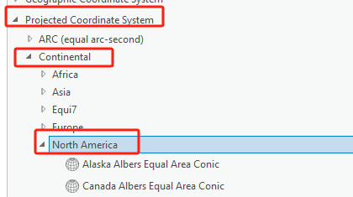
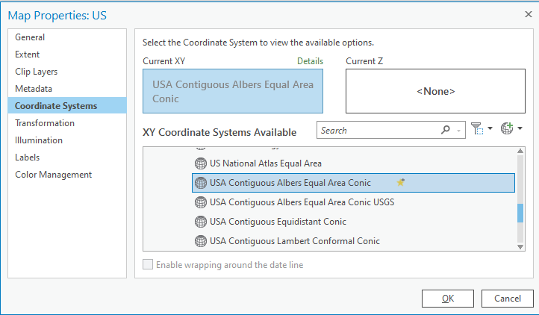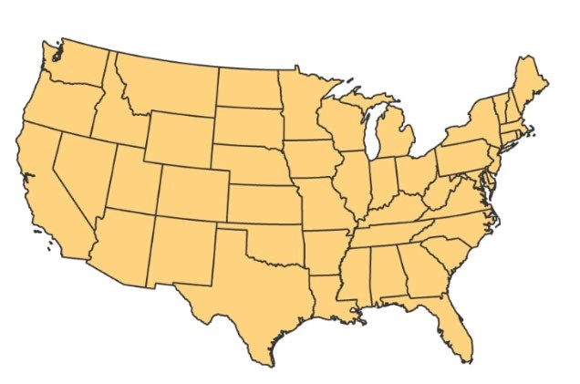

The map should now be
projected to an Albers Equal
Area Conic projection. The
shape of the United States
should change to reflect the
projection.
- You can also check the detail information (e.g., datum) of USA Contiguous Albers Equal Area Conic by clicking on Details .
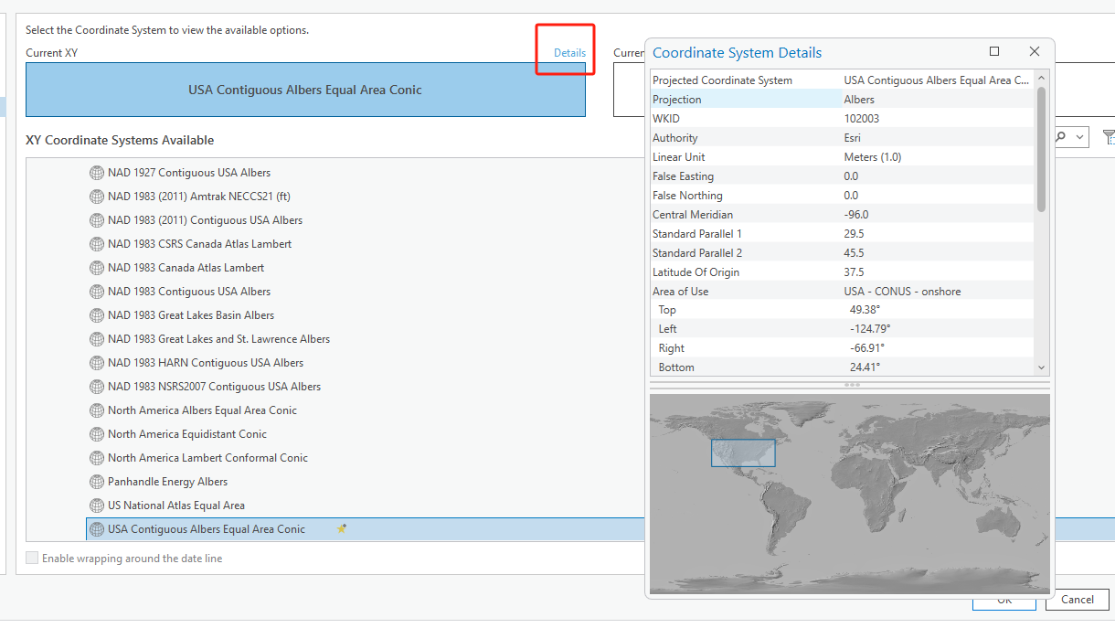

- Now, please follow the same steps to change the projection to Lambert Conformal Conic (use USA Contiguous Conformal Conic). This can also be found in the North America folder.
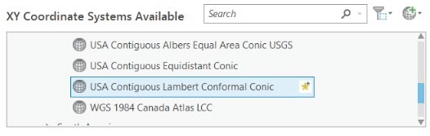

Question 7. What property (distance, local angels, area, shape) are conformal projections designed to maintain? (4 Points)

Step 4. Investigating World Projections
Now, you will explore some global projections. We commonly see more distortions for global scale maps as we are transforming the entire curved surface of the Earth to a flat surface.
- Navigate to the World Map.
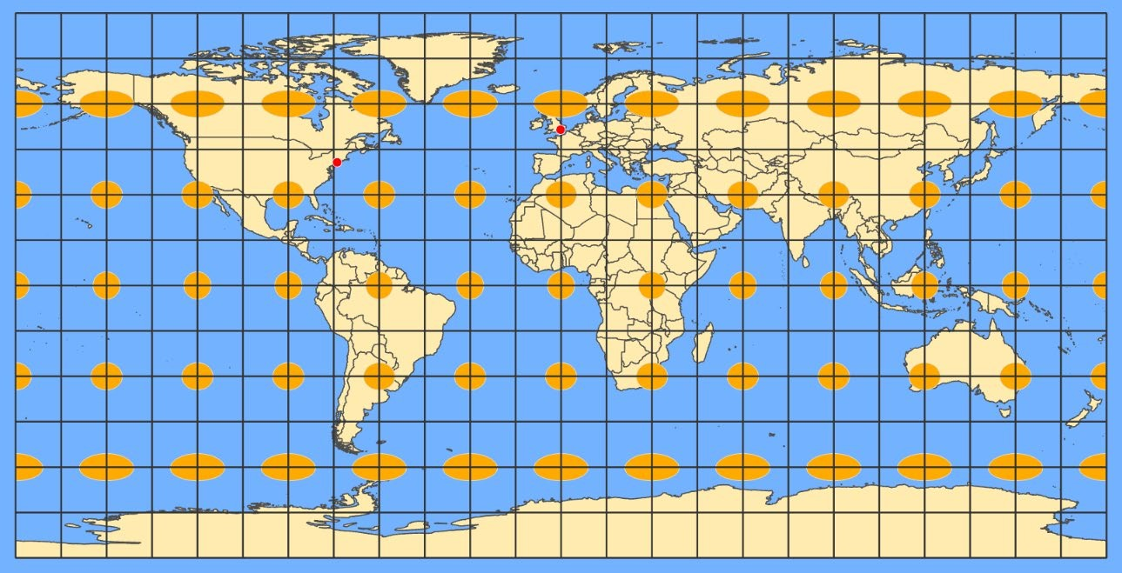
We will begin by measuring the distance between New York and London, shown on this map as red points.
Before that, you will change the projection for this global map to a Mercator projection.
- Right-click on World in the Contents Pane. Select Properties.
- In the Map Properties window, navigate to Coordinate System.
- Use the Mercator (world) projection. This can be found under Projected Coordinate Systems and in the World list. You can also click on the Details to find the datum information for Mercator projection.
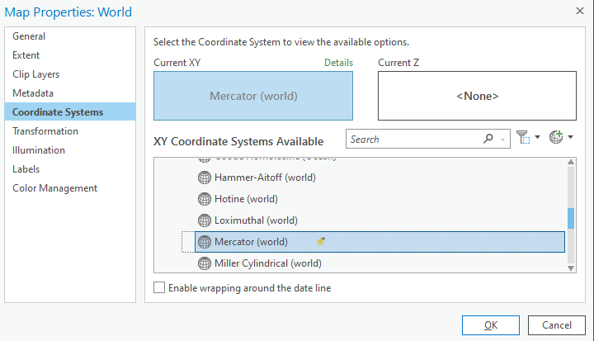

- Click OK to change the projection.
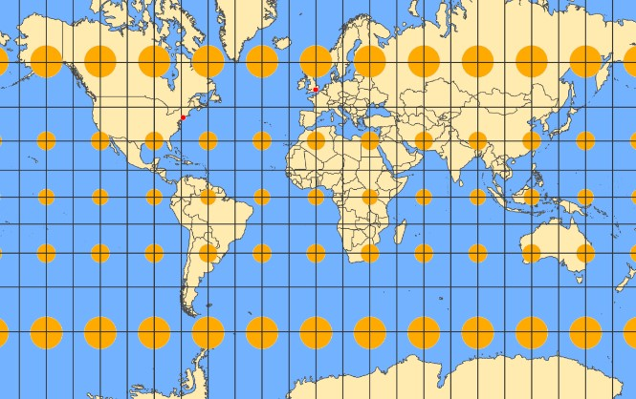

Note that if there are no projection distortions, the Tissot Ellipse (Tissot Indicatrix), shown on the map in orange, will all be the same size (relative to each other) and shape (perfect circles). Use the Tissot Ellipses to answer the following questions.

Question 8. Does the Mercator projection distort size? (4 Points)
Now measure the distance between New York and London.
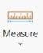
- Use the Measuring Tool to measure the distance between New York and London. This tool can be found in the Inquiry area of the Map Tab.
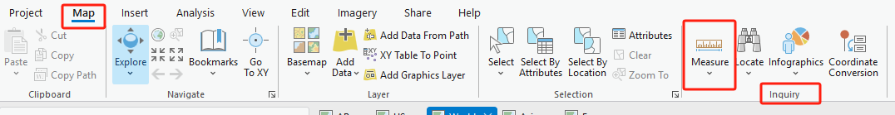
- In the tool options, change the distance units to kilometers. Select Planar for the distance.
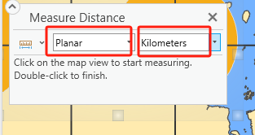

Question 9. What was the reported distance in kilometers between New York and London (they are red points on the map)? (3 Points)

(Hint, be careful when measure the distance. If you got two segments, which means you click twice by wrong. You also need to double-click to finish.)
- Now, change the projection to Mollweide (world). This projection is also in the World list under Projected Coordinate Systems.

Question 10. Does the Mollweide projection distort shape? (4 Points)

Question 11. Again, measure the planer distance between New York and London. Does the distance change compare the one in Question 9? (4 Points)
As you can see from these examples, different projections distort different properties. This is one of the primary considerations when choosing a projection for your map. What properties do you wish to maintain and which can be distorted?
Some projections attempt to strike a balance between distortions. One example is the Robinson Projection.
- Change the projection to Robinson (world). This projection is also in the World list under Projected Coordinate Systems.
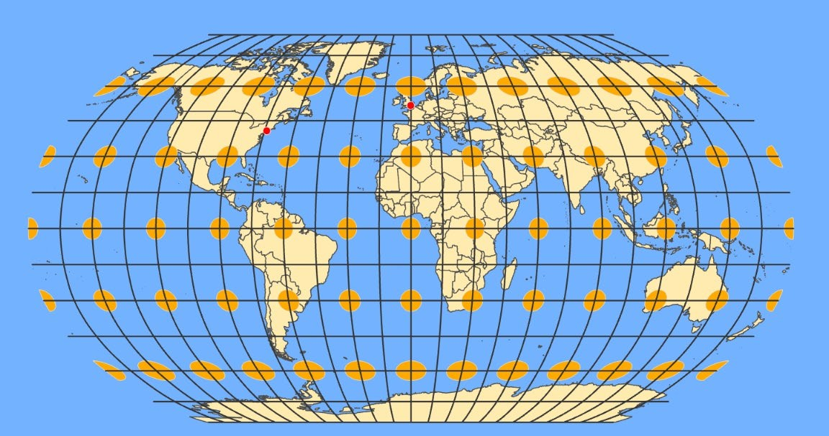
Note that the Robinson Projection distorts both size and shape, but attempts to balance out the distortions.
Before we move on, let’s investigate a polar projection.
- Change the projection to North Pole Azimuthal Equidistant. This projection is in the Polar list under Projected Coordinate Systems.
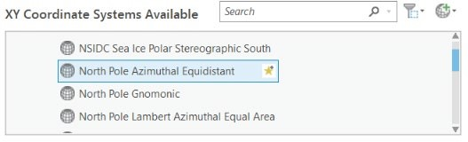
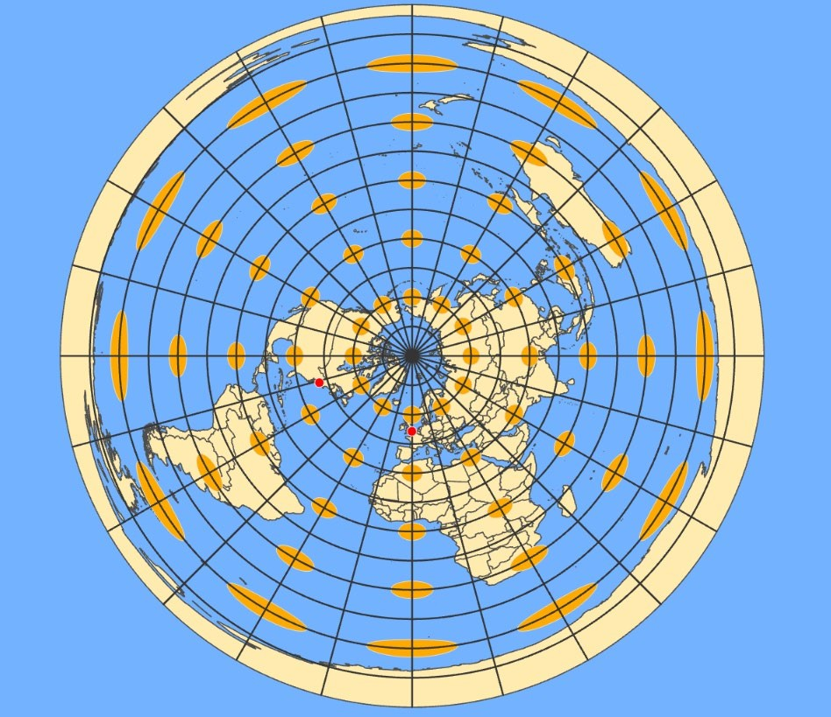
This projection maintains distance from the North Pole to other locations on the globe.
Take the time to experiment with some different map projections for projecting the entire globe. Projections designed for global maps are in the World list under Projected Coordinate Systems.
You can also measure the distance from New York and London to explore whether the distance changes or not under different projections. Note, the current mode is Planar. Change the mode to Geodesic to see how the distance changes.
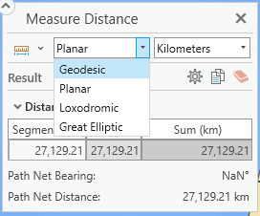
Geodesic distance is calculated in a 3D spherical space as the distance across the curved surface of the world (e.g., sphere or ellipsoid). Geodesic distance on the sphere can also be called great-circle distance, the shortest distance between two points on the surface of a sphere. The Planar distance, which is a straight-line Euclidean distance calculated in a 2D Cartesian coordinate system. The difference between Geodesic distance and planar distance can be seen in following figure. The Geodesic distance will be changed only the datum is changed, while the planar distance will be changed if the projection is changed.
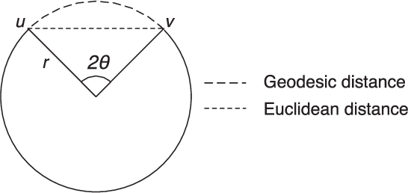
(source Tekir et al., 2011)

Step 5. Continental Scale Projections for Asia
We will now explore projections designed for Asia.
- Navigate to the Asia Map.
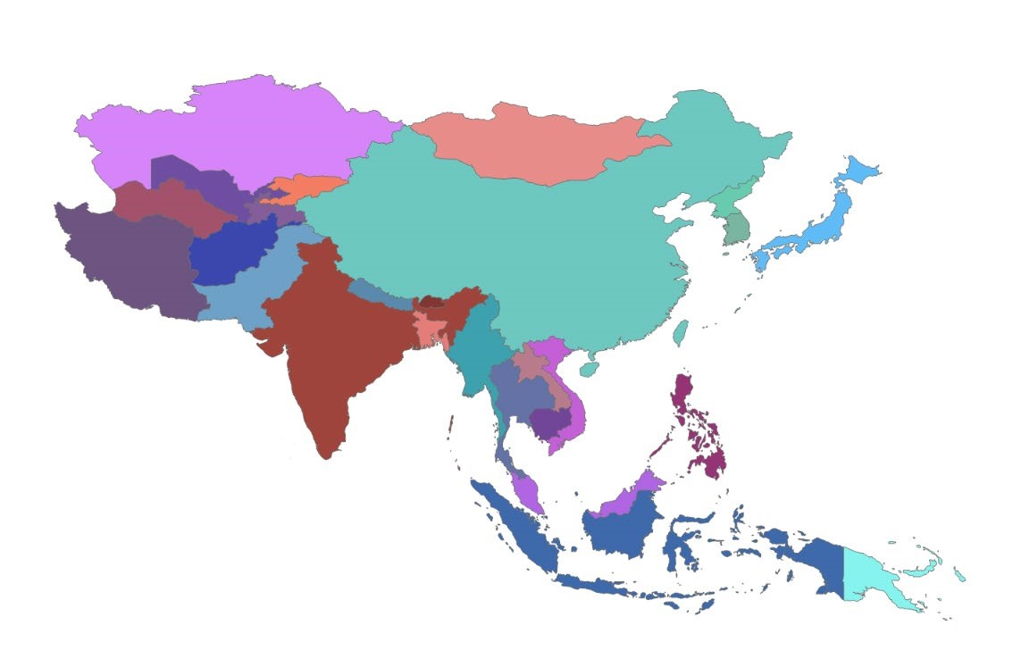
Projections that would be appropriate for Asia can be found in the Asia list under Continental and Projected Coordinate Systems. Experiment with the available projections to answer the question below.

Deliverable 1. Provide a screenshot of Asia map using Asian Lambert Conformal Conic projection that can maintain the relative shape of the countries. (4 Points)

Step 6. Continental Scale Projections for Europe
We will now explore projections designed for Europe.
- Navigate to the Europe Map.

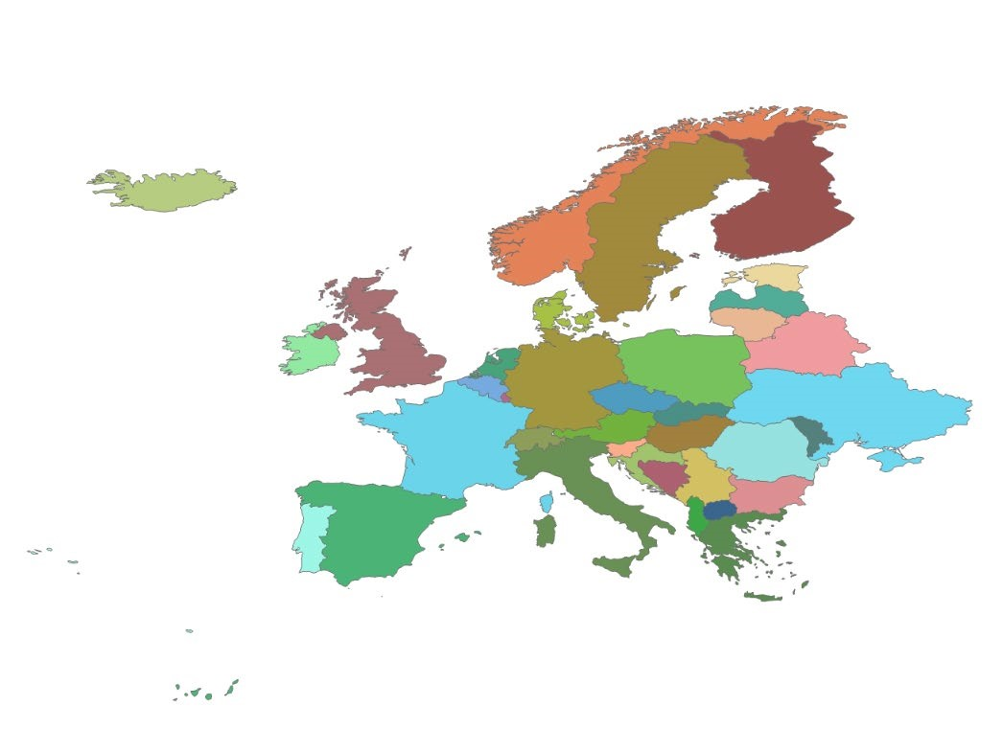
Projections that would be appropriate for Europe can be found in the Europe list under Continental and Projected Coordinate systems. Experiment with the available projections to answer the question below.

Deliverable 2. Provide a screenshot of Europe map using Europe Alberts Equal Area Conic projection that can maintain the relative area of the countries. (4 Points)

Step 7. Re-projecting a Layer
So far, you experimented with changing the projection of maps. Note that this process re-projects the data on-the-fly and changes the projection of the screen display. It does not change the actual projection associated with the data layer. If you wanted to save a copy of a data layer with a different projection applied, this can be done using the Project Tool. This tool can be found in the Projections and Transformations subtoolbox within the Data Management Toolbox (AnalysisToolsToolboxes). This tool will create a copy of a data layer with a new projection. If you are going to perform spatial analysis, it is generally a good idea to have all of the data layers in the same projection. So, you could use this tool to pre-process your data. In this step, you will learn how to re-project the data layer.
Return to AR map, you will change the projection for County layer to a new one.
- Click on Tools in the Analysis Tap.
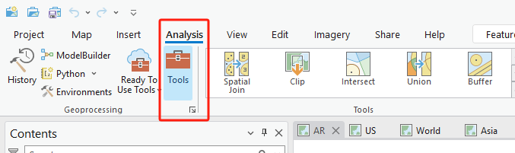

- In the Geoprocessing window, click on Toolboxes, followed by Data Management Tools and Projections and Transformations.
- Click on Project
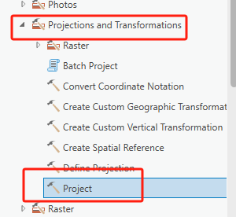

Note: Project tool is only for vector data. If you want to re-project raster data, you need to click on Raster followed by Project Raster.
- In the Project window, set the Input Dataset or Feature Class to County
- Set the Output Dataset or Feature Class to County_reProject. The default place to store County_reProject is the Exercise_2 geodatabase (i.e., Exercise_2.gdb) under Exercise_2 folder. You will learn geodatabase in the following lectures. If you want to change a place to store your reprojected data, you can click on the file icon .
- Set the Output Coordinate System to NAD 1983 Contiguous USA Albers. You can do it by clicking on the Earth icon , followed by Projected Coordinate Systems, Continental, North America, and NAD 1983 Contiguous USA Albers.
- Click on OK to return to Project window.
- You do not need to change others.
- Click on Run to execute the re-projection.
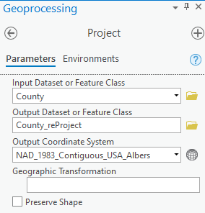
You may need to wait for a while, especially if your data is large. You will see a sign to tell a successful re-projection. 
The converted map County_reProject is automatically added to the Contents panel. You may notice there is no difference between the layer before re-projection and after. This is because ArcGIS Pro has the on-the-fly projection, which means it will automatically display the projection system as the data layer that firstly loaded into ArcGIS Pro. To see the difference, you need to create a new map to host the converted data layer.
- Click on New Map under Insert Tab. An empty map named Map should be loaded.
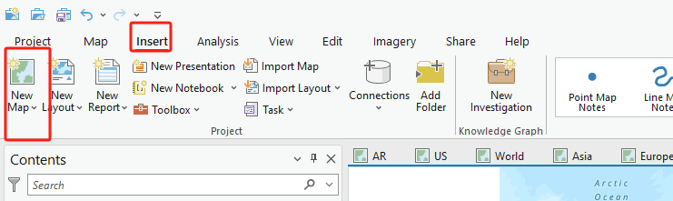
- Change the name of Map to AR ReProjection. This can be done by double-clicking on Map, followed by General. Set the Name to AR ReProjection and click on OK.
- Click on Add Data under Map Tab. Navigate to Exercise_2 folder. Within this folder, there should be a database called Exercise_2.gdb. Double-click on the database, highlight County_reProject and click on OK. The converted map is added to the map.

Question 12. Comparing the Arkansas map before and after reprojection, tell the difference (4 Points)

Deliverable 3. Provide a screenshot of Arkansas map with the new projection (4 points)

END OF EXERCISE

Homework
Submit a word file with 12 questions and corresponding answers together with three deliverables. Please submit it through Blackboard.

